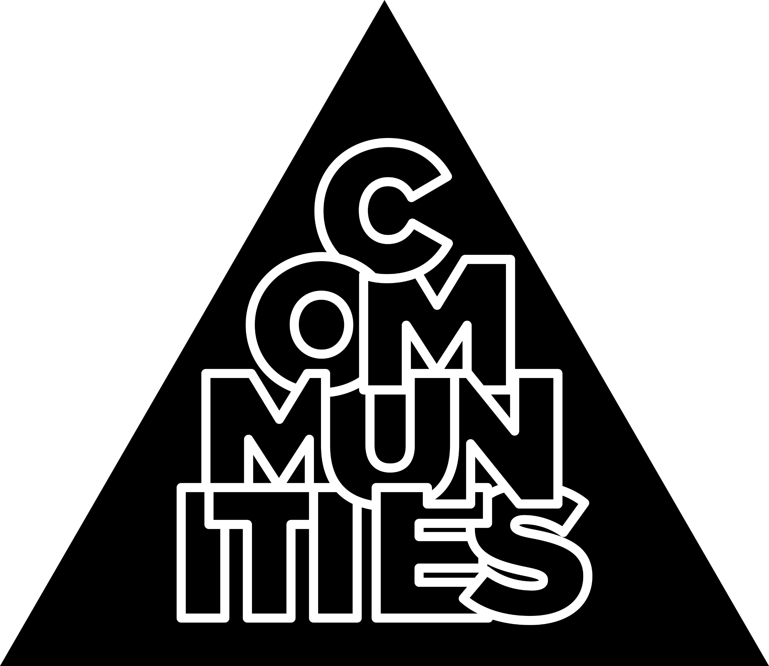

Community Project Plan
Community Name
Community Leader(s)
What is the project aim?
When is the project due?
Who will the project engage?
Why is it needed?
Who will you need to work with?
Scope
Actions
What do we already know?
What do we need to find out?
What steps will we take to complete our project?
Who will be responsible for what?
Resources & Support
What resources do you already have access to?
What additional resources do you need and how will you get them?

How will you fund your project?
Outline details of SU support required
Impact
What would success for your project look like?
How will you measure and build on impact?

